

AI-Powered Content Generation Engine for Small Businesses (IT)

- Hailu Tesfaye s8137538
- Daniel Palazzolo s8177269
- Semir Abdu s4672665
- Jamal Hussein s8081019

Introduction 3
1.1 Background 3
1.2 Problem Statement 4
1.3 Proposed Solution 5
1.4 Project Aim and Objectives 6
1.5 Project Scope 7
1.6 Significance of the Project 8
2 Functional Requirements 9
2.1 Overview 9
2.2 Front-End Functional Requirements 9
2.3 Business Profile Management 10
2.4 Content Generation 10
2.5 Content Storage and Management Dashboard 11
2.6 Server-End Functional Requirements 11
2.7 Data Storage Requirements 12
2.8 Database Requirements 12
2.9 System Flow 15
3 - Non-Functional Requirements 16
3.1 System Scalability and Multi-tenancy 16
3.2 System Reliability and Uptime 16
3.3 Performance and Latency 17
3.4 Security and Data Privacy 17
3.5 Usability and User Experience (UX) 17
4 USE CASE 18
4.1 Use Case 1: Create and update Business Profile 18
4.2 Use Case 2: Generate AI Marketing Content 18
4.3 Use Case 3: Manage Saved Content 19
4.4 Use Case 4: Rate and improve Al Content 19
4.5 Use Case Diagram sketch 20
5.1 System Interaction Overview 21
5.2 Sequence Diagram Image (see image below) 22
5.3 UML Source Code 23
6 - Pseudocode 24
6.1 Content Generation Algorithm 24
6.2 Content Quality Evaluation Sub-Algorithm 28
7 - UI Design 32
7.1 Login Page Design 33
7.2 Dashboard Design 34
7.3 Content Generator Interface 35
8 - Resource Management 37
8.1 Introduction 37
8.2 Identification and Justification of Required Resources 37
8.2.2 Technology and Software Resources 38
8.2.3 Time Resources and Scheduling 38
8.3 Contingency Planning and Monitoring 39
9 Risk Management 40
9.1 Risk Identification 40
9.2 Risk Mitigation Strategy 41
10 Timeline & Milestone 42
10.1 NIT3003 – IT Capstone Project 1 42
10.2 Project implementation 44
10.3 NIT4001 – IT Capstone Project 2 46
10.4 Contingency Planning 47
11 Conclusion 48
12 Contribution table 49
13 . Reference 51

Introduction

1.1 Background
Digital transformation has changed the way businesses connect with customers, promote their products, and compete. Small businesses now use websites, social media, and email marketing to reach their audiences and maintain visibility. However, creating regular and engaging content across different channels requires time, creativity, and skills that many small business owners do not have.
Recent advances in Artificial Intelligence, especially Generative AI, allow businesses to automate tasks such as content creation, customer engagement, and data-driven communication. Generative AI can produce new content and is rapidly transforming marketing by helping organisations create personalised and scalable messages (Cillo & Rubera, 2024). These developments show that AI can help businesses work more efficiently while still connecting with customers in meaningful ways.
Even though AI tools are becoming more common, organisations often find it difficult to integrate them into their regular marketing processes because this requires changes to both technology and business operations (Keegan et al., 2022). This highlights the need for simple solutions that allow small businesses to benefit from AI without requiring advanced technical skills.
Research also shows that using AI and digital technologies can improve how companies operate and support better data-driven decision-making, particularly when these tools are implemented through structured digital platforms (Rosário & Raimundo, 2025). For small and medium-sized businesses, adopting AI in digital marketing can support growth and improve competitiveness in today’s markets (Liando et al., 2024). These developments create an opportunity to design an AI-powered platform tailored specifically for small businesses, enabling them to produce marketing content more efficiently while using fewer resources.

1.2 Problem Statement

Digital marketing plays a key role in business success, but many small businesses struggle to maintain a strong online presence. Creating quality marketing content takes time, skill, and money—resources that small businesses often do not have. Since owners handle many responsibilities, it can be difficult for them to regularly plan, write, and update content for blogs, social media, and email campaigns.
​
AI technologies can help automate marketing, but many businesses find them hard to use. Integrating artificial intelligence into existing processes can be complex and often requires technical skills that small businesses may not have (Keegan et al., 2022). As a result, many AI tools are too technical, too expensive, or not built for small business needs.
​
Research shows that while AI-driven digital marketing can help small and medium businesses grow and compete, these businesses often lack simple tools to make the most of these benefits (Liando et al., 2024). This leads to a gap between what AI marketing can offer and what small businesses can actually use.
​
Small business owners need an easy, affordable platform to create marketing content quickly, without advanced technical skills or a big budget.
There are many AI-based content and marketing tools available today, but most are made for large organisations or need a complex setup and expensive subscriptions. Many current solutions focus on just one feature, such as text generation or analytics, rather than offering a simple, all-in-one workflow for small businesses. Because of this, small businesses often find these tools hard to use or not a good fit for their needs, underscoring the need for a user-friendly, affordable platform designed for SMEs (Liando et al., 2024).

1.3 Proposed Solution
There are already many AI-powered content creation tools available, such as ChatGPT-based writing assistants like Jasper and Copy.ai, as well as marketing tools with built-in AI features. These tools show that more businesses are seeking automated content and that AI is becoming increasingly important in marketing. They can quickly create text, handle various content types, and help marketing professionals work more efficiently.
However, these tools often have drawbacks for small businesses. Many expect users to know how to set up prompts, plan marketing strategies, or handle technical details, which can be hard for people without a background in these areas. Also, most are made for large companies or serve as separate tools, not as part of a system designed for small-business needs. As Keegan et al. (2022) point out, organisations often struggle to integrate AI into their existing processes, especially when the tools are not easy to use or the business is not ready for them.
These issues show that current AI tools do not fully meet the real needs of small and medium-sized businesses. Studies have found that while AI marketing tools can help these businesses grow and compete, there are still not enough easy-to-use options available (Liando et al., 2024).
To solve this problem, this project suggests creating an AI-powered content generation tool made for small businesses. The tool will be a cloud-based service that allows users to create professional marketing content quickly and easily, even if they lack technical skills. Users will enter key business details, such as brand voice, products, and target audience. The system will then use this information to work with a large language model to generate blog outlines, social media posts, and email newsletters.
The platform will also include editing and analysis tools to assess tone and keyword use, ensuring the content aligns with marketing goals. Using AI and digital tools in this way can help organisations work more efficiently and make better decisions (Rosário & Raimundo, 2025).
To maintain high-quality and relevant AI-generated content, the proposed system will include a content evaluation module. This module will assess generated text using predefined metrics such as readability scores, keyword relevance, and tone consistency with the brand voice. For example, readability will be measured using standard metrics like the Flesch Reading Ease score, while keyword matching will ensure content aligns with the business’s target audience and marketing goals. The platform will also enable users to provide feedback through a simple rating system. This feedback will help refine prompt structures and enhance the quality of future outputs. By combining evaluation metrics and user feedback, the platform offers a more structured and reliable AI-assisted marketing workflow.

1.4 Project Aim and Objectives
Project Aim
The aim of this project is to develop an AI-powered Software-as-a-Service (SaaS) platform that enables small businesses to efficiently generate high-quality, personalized marketing content. The platform will be simple to use and affordable, allowing businesses to improve their online presence and remain competitive without requiring advanced technical skills.
Project Objectives
To achieve this aim, the project will pursue the following objectives:
- Develop a system that allows multiple businesses to securely access and manage their own accounts within a shared platform environment.
- Design an easy-to-use interface that enables business owners to define their brand voice, products, and target audience without technical expertise.
- Implement a Content Generator capable of producing a variety of marketing materials, including blog outlines, social media posts, and email newsletters.
- Integrate the platform with a Large Language Model through prompt engineering to ensure generated content aligns with each business’s profile and marketing goals.
- Provide editing and content management tools that allow users to review, modify, and save AI-generated drafts before use.
- Include analytics features to evaluate tone and keyword relevance, helping businesses create content that matches their marketing strategies and audience needs, thereby supporting the adoption of AI-powered marketing (Liando et al., 2024).

1.5 Project Scope
This project will develop a prototype of an AI-powered content-generation platform for small businesses. The goal is to show how Generative AI can be used in a straightforward SaaS setup to help with marketing content creation and management.
In Scope
The project will include these features:
- Build a secure platform that allows multiple businesses to create and manage their own accounts.
- Create a user interface that allows businesses to enter their brand details, product information, and target-audience information.
- Add a Content Generator that uses AI to create blog outlines, social media captions, and email marketing drafts. Connect the platform to a Large Language Model to generate content tailored for each business.
- Include a built-in editor that lets users review, edit, and save the content they create. Add basic analysis tools to check the tone and keyword relevance of the marketing materials.
- Deploy the platform in the cloud to simulate a SaaS model accessible via a web interface.
Out of Scope
To keep the project manageable within the timeline, these features will not be part of the scope:
- Full automation of marketing campaigns or scheduling across external platforms.
- Integration with third-party CRM or advertising systems.
- Image, video, or multimedia content generation.
- Advanced analytics, such as real-time customer behaviour tracking.
- Commercial deployment or live production use beyond the prototype environment.
By setting these boundaries, the project stays focused on showing how Artificial intelligence can be used for marketing content generation and makes sure the goals can be met within the academic timeframe.

1.6 Significance of the Project

This project matters because it addresses a real problem for many small businesses: maintaining consistent, high-quality digital marketing when resources are tight. By using Generative AI on a straightforward, easy-to-use platform, the system shows that advanced technology can help small businesses with daily operations, not just large companies with expert teams.

Using AI tools in marketing can boost productivity, help businesses make better data-driven decisions, and improve how they connect with customers when these tools are part of well-designed digital solutions (Rosário & Raimundo, 2025). For small and medium-sized businesses, adopting Artificial intelligence in marketing can help them grow and stay competitive as markets become more digital (Liando et al., 2024). This shows why it is important to create solutions that make AI easier to use and more available to everyone.

This project offers an automated and flexible content creation system, showing that AI can do more than just save time; it can help small businesses take a bigger role in the digital economy. It also adds to our understanding of how new Artificial intelligence technologies can be used in real business settings to support innovation, growth, and inclusion.

2 Functional Requirements

2.1 Overview
This section outlines the functional requirements for the AI-powered content generation system. Functional requirements describe the specific functions and services the system has to offer to the users.
The proposed system shall operate as a Software-as-a-Service (SaaS) platform, allowing users to utilize the software through a web browser without installing software (Microsoft, 2023).
The system will use Generative AI to generate marketing content for small businesses. Generative AI is commonly utilized to boost productivity in marketing and business tasks (McKinsey & Company, 2023).

2.2 Front-End Functional Requirements
The front end is what the users will see and interact with when browsing.
The system shall allow users to:
- Authentication: Users will be able to register, log in, and log out by using email and password
- Validation: Every required field must be filled out; if not, an error message will be shown
- Security: The system will not store passwords in plain text. To boost security, they will be saved in hashed form, in accordance with established security procedures (OWASP Foundation, 2023).

2.3 Business Profile Management
After successful login, the system shall allow the user to create and update a business profile, including the following:
- Input Fields: Users provide the target audience, such as Product description and industry selection, with a dropdown selection
- Brand tone: Users can select tones such as ( Professional, Casual and Friendly )
- Verification: All fields are mandatory. The system shall verify that all mandatory fields are complete before generating content.

2.4 Content Generation
The system will provide a structured workflow for generating marketing content.
Content Options: The system shall allow users to select a content type, such as an Instagram caption, an email draft, or a blog outline
When the user clicks the “Generate” button:
- The system will send the business information to the server.
- The server will verify the data.
- The server constructs a structured prompt based on the profile of the business and the industry
- The server will send a request to the AI server.
- The AI service will generate marketing content.
- The system carries out an evaluation to score the content based on readability and brand tone before finalization.
- The system will display the generated content on the screen
The user will be able to:
- Save the content
- Copy the content
- A feedback rating from 1 to 5 stars is provided by the system, with this being weighted at 35% in the algorithm used for evaluation
- The system will process only one AI generation request per user at a time.

2.5 Content Storage and Management Dashboard
The system will provide a dashboard where users can
- View an overview of stored content, including the total number of drafts, average quality score percentage, and the monthly generation limit."
- See content type
- See the date of creation
- Delete your saved content
- Users can only access their own content
- The user can view the star rating and the detailed quality score metrics (Readability, Tone and Keywords) for their saved content.

2.6 Server-End Functional Requirements
The server will manage user authentication, AI requests and database storage
The server will:
- Encrypt all communication between the user and the server using HTTPS (TLS)
- Ensure that passwords are not stored in plain text and are protected using secure hashing
- Data verification: Verify login credentials and profile information before sending any request to the AI service.
- The server shall create a session after a successful authentication. The system shall restrict access to protected features if the user is not authenticated.
The server shall confirm if all requested fields are completed before processing requests.
When the user clicks the “Generate” button, it will:
- The server will verify that the user is authenticated.
- The server will collect the user’s business information.
- The server will create a structured prompt.
- The server will forward the prompt to the AI API.
- The AI server will return the generated content to the server.
- The server will transmit the generated content back to the user interface.

2.7 Data Storage Requirements
The system shall store generated content in a database.
Each record will include the following:
- User ID
- Generated content
- Content type
- The date and time when the content was created.
- Quality Score: A numerical value score between 0.0 and 1.0 that represents the effectiveness of the AI output
- Analysis JSON: A data object that represents the analysis of readability, tone markers and keyword integration
The system shall use foreign keys to link content to the correct user.

2.8 Database Requirements
The system will use three tables.

User Table
This table is responsible for the authentication and security of the SaaS Platform, guaranteeing that each business owner has a unique and secure account.
Field | Type | Description
Id | INT (primary key) | Unique identifier for the account holder
email | VARCHAR(255) | The user’s unique login address
password | VARCHAR(255) | Securely hashed user credentials
Created_at | DATETIME | Timestamp of when the account was first registered

Business_Profile Table
This table contains the brand identity and context that will be used to inform the prompts that the AI will receive, which will be used to create the marketing content that is specific to each business.
Field | Type | Description
id | INT (Primary key) | Unique identifier for the business profile
User_id | INT (Foreign key) | Associate the profile with the correct registered user
Business_name | VARCHAR(255) | The official name of the business
industry | VARCHAR(100) | The sector the business operates within (e.g. hospitality, Retail).
description | TEXT | A summary of the business’s core products/services
Target_audience | TEXT | Information on who the content is being written for
Brand_tone | VARCHAR(50) | Voice to be used (e.g. Professional, Casual).

Generated_Content Table
This table is the core feedback loop that will be used to create higher-quality content in the future, using the outputs from the AI, the automated quality metrics and the star ratings provided by the users.
Field | Type | Description
Id | INT (Primary key) | A unique identifier for the drafted content
User_id | INT (Foreign key) | Links the content to the user’s dashboard.
Content_type | VARCHAR(100) | Identifies the format (e.g instagram Caption).
Content_text | TEXT | The raw marketing text generated by the AI
Quality_Score | DECIMAL(3,2) | The 0.0 - 1.0 efficiency score was calculated from the automated evaluation.
Analysis_JSON | TEXT/JSON | Detailed data on the breakdown of the readability and keywords.
Rating | INT | The 1-5 star manual rating assigned by the user.
Created_at | DATETIME | Timestamp of when the content was generated.

Example:
Id | User_id | Content_type | Created_at
10 | 1 | Instagram Caption | 2026-04-02

2.9 System Flow
The system will operate according to the following workflow
- The user registers and logs in
- The user provides business information
- The user selects a content type,
- The user clicks on the “Generate” button.
- The server sends a request to the AI service.
- The AI generates marketing content.
- The server stores the content in the database.
- The system displays the generated content to the user.
- The user can save or erase the content.
This demonstrates how the front-end, server, AI service and databases all work together.

3 - Non-Functional Requirements

3.1 System Scalability and Multi-tenancy
As the platform utilises a SaaS model to support multiple small business accounts simultaneously, the system must employ a robust multi-tenant architecture. The database design must ensure strict logical isolation of tenant data to prevent data leakage between competing businesses. The system must be capable of scaling horizontally to support a minimum of 50 concurrent users during the prototype phase without performance degradation. Furthermore, the backend infrastructure must handle simultaneous API requests to the external Large Language Model (LLM), implementing a queuing system to manage rate limits if the request volume exceeds 100 requests per minute.

3.2 System Reliability and Uptime
Small businesses rely on consistent marketing activity for growth; therefore, the platform must achieve a target availability of 99.9% during business hours (9:00 AM – 5:00 PM AEST). To mitigate the risk of "hallucinations" or factual errors common in Generative AI (Cillo & Rubera, 2025), the system must implement an error-handling feedback loop. If the external AI API fails or times out, the system must degrade gracefully by preserving the user’s input data locally and displaying a user-friendly error message within 1 second, rather than crashing the application session.

3.3 Performance and Latency
While Generative AI processing is computationally intensive, the user interface must remain responsive to encourage adoption among non-technical business owners.
- Interface Latency: The dashboard and content editor interfaces must load within 2 seconds on standard broadband connections (Sample 01, 2025).
- Generation Latency: Acknowledging that LLM generation takes time, the "Content Generator" module must initiate the request immediately and provide a visual progress indicator. Short-form content (e.g., social media captions) must be generated within 15 seconds, while long-form content (e.g., blog outlines) must be completed within 45 seconds.

3.4 Security and Data Privacy
Given that the platform processes proprietary business data and customer profiles, security is paramount to building trust. All data transmission between the client, the SaaS server, and the external AI provider must be encrypted using HTTPS (TLS 1.3). To protect user credentials, passwords must be hashed and salted using bcrypt or a comparable algorithm before storage. Additionally, considering the ethical concerns regarding AI data privacy (Rosário & Raimundo, 2025), the system must not use user-specific proprietary data to train the shared public model unless explicit consent is granted. API keys used to integrate with the LLM must be stored in secure environment variables, never exposed in the client-side code.

3.5 Usability and User Experience (UX)
Adopting AI technology can be daunting for small business owners lacking technical expertise (Keegan et al., 2024). Therefore, the system must prioritise a high level of usability. The interface for defining the "Brand Voice" and "Target Audience" must utilise clear, non-technical language and tooltips, ensuring that a user can complete a content generation task with fewer than 5 clicks after logging in. The design must be responsive, fully functional on both desktop (1920x1080) and tablet devices, catering to business owners managing operations on the go (Liando et al., 2025).

4 USE CASE
Brief Description: This section describes how the user will interact with the system step-by-step

4.1 Use Case 1: Create and update Business Profile
Primary Actor: The registered user
Pre-conditions: The user is logged in
Main flow:
- The user navigates to the Business Profile section.
- The user fills in the business name, industry and target audience.
- The user chooses a “Brand Tone” from the drop-down list.
- The user clicks on “Save Profile.”
Alternative Flows: if any mandatory fields are left blank, the system displays an error message stating “Please fill in all fields.”

4.2 Use Case 2: Generate AI Marketing Content
Brief Description: This is the main feature where the system generates content using AI based on the profile provided by the user.
Actor: Registered User
Pre-conditions: The Business Profile is filled in.
Main Flow:
- The user chooses a type of content(for example, an Instagram caption).
- The user clicks the “Generate” button.
- The system shows the generated text on the screen.
Post-conditions: The content is automatically saved to the dashboard

4.3 Use Case 3: Manage Saved Content
Brief Description: This will allow the user to see their history of generated content and remove unwanted entries.
Actor: Registered User
Pre-conditions: The user must have previously saved content.
Main Flow:
- The User goes to the “Dashboard” tab.
- The system retrieves all saved records for that specific User ID.
- The user browses the list and chooses a record to delete.
Post-conditions: The record is deleted from the database.

4.4 Use Case 4: Rate and improve Al Content
Brief Description: This describes exactly how the user interacts with the rating tool
Actor: Registered User
Pre-conditions: The content has already been written by the AI, and it is displayed on the screen.
Main Flow:
- The user reads the marketing content created by the AI.
- The user sees 5 stars displayed below the content.
- The user clicks on the 5-star scale to choose a rating from 1 to 5 stars.
- The system stores the “Star Count” and “Content ID” in the database.
- The system calculates a User Satisfaction Score (weighted at 35% of the total quality score) to refine future AI generations.
- The system automatically saves high-rated content (4 – 5 stars ) to the top of the user’s “Top Favourites” list
Post-conditions: The user’s rating is stored, the dashboard re-ranks, and the system updates the paired dataset of automated metrics and user feedback to improve prompt accuracy for that specific industry.

4.5 Use Case Diagram sketch

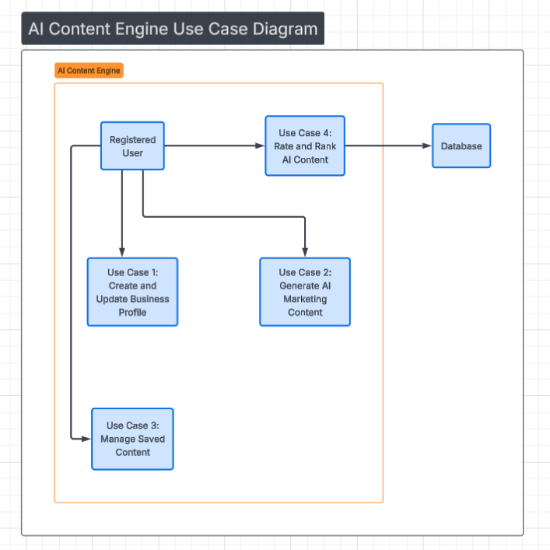
5. SEQUENCE DIAGRAM

5.1 System Interaction Overview
The sequence diagram below illustrates the end-to-end architecture of the AI-Powered Content Generation Engine. To directly address the engineering challenge of evaluating AI output quality, the system workflow integrates an automated benchmarking phase. After the external LLM (OpenAI API) generates the content, the Vercel Backend automatically routes the output to an Evaluation Engine (e.g., Twinword or a secondary NLP script). This engine scores the content for brand tone alignment and SEO keyword density against the user's stored profile. The system incorporates robust edge-case handling, including retry logic for API timeouts and graceful fallbacks, ensuring high reliability (linking directly to our Non-Functional Requirements for 99.9% uptime and low latency).

5.2 Sequence Diagram Image (see image below)
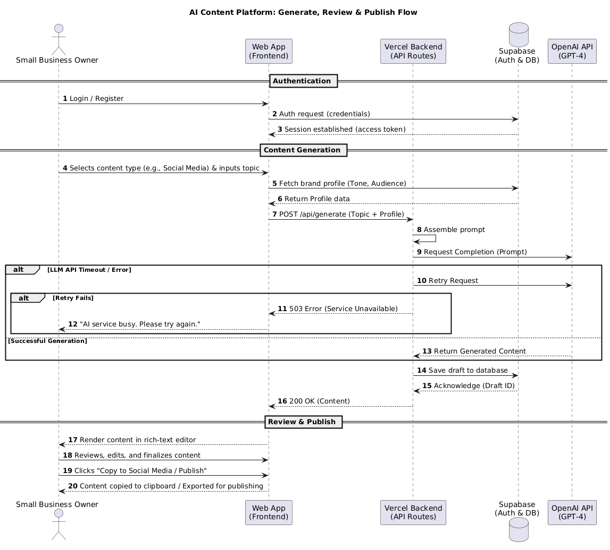

5.3 UML Source Code

@startuml
title AI Content Platform: Generate, Review & Publish Flow
autonumber

actor "Small Business Owner" as User
participant "Web App\n(Frontend)" as FE
participant "Vercel Backend\n(API Routes)" as BE
database "Supabase\n(Auth & DB)" as DB
participant "OpenAI API\n(GPT-4)" as LLM

== Authentication ==
User -> FE : Login / Register
FE -> DB : Auth request (credentials)
DB --> FE : Session established (access token)

== Content Generation ==
User -> FE : Selects content type (e.g., Social Media) & inputs topic
FE -> DB : Fetch brand profile (Tone, Audience)
DB --> FE : Return Profile data
FE -> BE : POST /api/generate (Topic + Profile)
BE -> BE : Assemble prompt

BE -> LLM : Request Completion (Prompt)
alt LLM API Timeout / Error
BE -> LLM : Retry Request
alt Retry Fails
BE --> FE : 503 Error (Service Unavailable)
FE --> User : "AI service busy. Please try again."
end
else Successful Generation
LLM --> BE : Return Generated Content
end

BE -> DB : Save draft to database
DB --> BE : Acknowledge (Draft ID)
BE --> FE : 200 OK (Content)

== Review & Publish ==
FE --> User : Render content in rich-text editor
User -> FE : Reviews, edits, and finalizes content
User -> FE : Clicks "Copy to Social Media / Publish"
FE --> User : Content copied to clipboard / Exported for publishing
@enduml

6 - Pseudocode

6.0 User Auth
The authentication flow is the gateway to every other operation in the system. Before a user can generate content, manage their profile, or access their dashboard, the system must verify their identity and establish a secure session. This algorithm handles both new registrations and returning logins through a single entry point, delegating credential storage and session management to Supabase Auth. The design separates registration from login to enforce profile completeness for new accounts — a user who registers but never completes their business profile cannot generate meaningful content, so the system routes them directly to onboarding.

FUNCTION authenticateUser(email, password, isNewRegistration)
// --- Phase 1: Input Validation ---
// Reject malformed inputs before they reach the authentication
// provider. This prevents unnecessary API calls and ensures
// consistent error messaging at the boundary.
IF email is empty OR NOT MATCHES email format THEN
RETURN error("Please enter a valid email address")
ENDIF
IF password is empty OR LENGTH(password) < 8 THEN
RETURN error("Password must be at least 8 characters")
ENDIF
// --- Phase 2: Registration or Login ---
// Supabase Auth handles password hashing (bcrypt), duplicate
// detection, and token issuance. The system does not store
// raw passwords at any point.
IF isNewRegistration THEN
TRY
authResponse = SUPABASE_AUTH.signUp(
email: email,
password: password
)
CATCH duplicateEmailError
RETURN error("An account with this email already exists")
CATCH error
RETURN error("Registration failed. Please try again.")
ENDTRY
ELSE
TRY
authResponse = SUPABASE_AUTH.signInWithPassword(
email: email,
password: password
)
CATCH invalidCredentialsError
RETURN error("Incorrect email or password")
CATCH error
RETURN error("Login failed. Please try again.")
ENDTRY
ENDIF
// --- Phase 3: Session Establishment ---
// On successful authentication, Supabase returns an access token
// and refresh token. The access token is stored client-side for
// subsequent API requests. The session is validated server-side
// on every protected route.
SET session = {
userId: authResponse.user.id,
accessToken: authResponse.session.accessToken,
refreshToken: authResponse.session.refreshToken,
expiresAt: authResponse.session.expiresAt
}
STORE session IN secure HTTP-only cookie
// --- Phase 4: Post-Authentication Routing ---
// New users must complete their business profile before they
// can generate content. Returning users are sent to the dashboard.
IF isNewRegistration THEN
REDIRECT to "/onboarding/business-profile"
ELSE
profile = GET_BUSINESS_PROFILE(session.userId)
IF profile is empty THEN
REDIRECT to "/onboarding/business-profile"
ELSE
REDIRECT to "/dashboard"
ENDIF
ENDIF
RETURN {
success: true,
session: session
}
ENDFUNCTION

6.1 Content Generation Algorithm
The content generation pipeline is the most algorithmically complex operation in the system. It is not a simple passthrough to the AI API.
Between the user's request and the final output, the system must assemble a context-aware prompt from stored business data, call the external model with fault tolerance, and then evaluate the quality of the returned content against measurable criteria before presenting it to the user.
This evaluation step is what distinguishes the platform from a generic ChatGPT wrapper and directly addresses the core engineering challenge: how do we know the AI output is actually good?

FUNCTION generateMarketingContent(userId, contentType, topic, keywords)
// --- Phase 1: Authentication and Rate Limiting ---
// Verify the user has an active session and has not exceeded
// their plan's monthly generation limit.
session = GET_SESSION(userId)
IF session is invalid THEN
RETURN error("User is not authenticated")
ENDIF
usageCount = GET_MONTHLY_USAGE(userId)
planLimit = GET_PLAN_LIMIT(session.planTier)
IF usageCount >= planLimit THEN
RETURN error("Monthly generation limit reached")
ENDIF
// --- Phase 2: Business Profile Retrieval ---
// Fetch the user's stored brand profile. This is the foundation
// of prompt personalisation -- without it, the AI has no context
// about the business and cannot produce brand-aligned content.
profile = GET_BUSINESS_PROFILE(userId)
IF profile is empty OR profile.brandTone is empty THEN
RETURN error("Business profile is incomplete")
ENDIF
products = GET_PRODUCTS(profile.id)
// --- Phase 3: Structured Prompt Assembly ---
// The prompt is not a raw user query. It is a structured instruction
// that combines the content type template, brand context, and user
// input into a single engineered prompt. This is where the system
// adds value beyond what a user could do manually with ChatGPT.
SET systemInstruction = BUILD_SYSTEM_PROMPT(
role: "marketing content specialist",
tone: profile.brandTone,
audience: profile.targetAudience,
industry: profile.industry
)
SET userPrompt = BUILD_USER_PROMPT(
contentType: contentType,
topic: topic,
keywords: keywords,
brandValues: profile.brandValues,
products: products
)
// Apply content-type-specific constraints
IF contentType == "Social Media Caption" THEN
APPEND to userPrompt: "Keep under 280 characters. Include a call to action."
ELSE IF contentType == "Blog Outline" THEN
APPEND to userPrompt: "Structure with H2 headings, intro, 3-5 sections, conclusion."
ELSE IF contentType == "Email Newsletter" THEN
APPEND to userPrompt: "Include subject line, preview text, body, and CTA button text."
ENDIF
// --- Phase 4: AI API Call with Fault Tolerance ---
// The external API is a point of failure. The system implements
// retry logic and model fallback to maintain availability.
SET retryCount = 0
SET maxRetries = 2
SET rawContent = empty
WHILE retryCount <= maxRetries DO
TRY
rawContent = CALL_GPT_API(
model: "gpt-4",
systemPrompt: systemInstruction,
userPrompt: userPrompt,
maxTokens: GET_TOKEN_LIMIT(contentType),
temperature: 0.7
)
BREAK // Success -- exit the retry loop
CATCH timeout OR apiError
retryCount = retryCount + 1
IF retryCount > maxRetries THEN
// Final fallback: attempt with lighter model
TRY
rawContent = CALL_GPT_API(
model: "gpt-3.5-turbo",
systemPrompt: systemInstruction,
userPrompt: userPrompt
)
CATCH error
RETURN error("Content generation unavailable. Input preserved.")
ENDTRY
ENDIF
ENDTRY
ENDWHILE
// --- Phase 5: Content Quality Evaluation ---
// This is the critical engineering layer. Rather than returning
// raw AI output directly, the system scores the content against
// measurable quality dimensions. This provides the user with
// actionable feedback and allows the system to auto-reject
// clearly poor outputs.
qualityReport = EVALUATE_CONTENT(rawContent, profile, contentType)
// --- Phase 6: Threshold Check and Auto-Regeneration ---
// If the overall quality score falls below the acceptable threshold,
// the system regenerates once with an adjusted prompt that includes
// the specific deficiencies as additional instructions.
IF qualityReport.overallScore < 0.6 THEN
SET adjustedPrompt = userPrompt
APPEND to adjustedPrompt: "Previous attempt scored poorly. Improve on: "
IF qualityReport.toneScore < 0.5 THEN
APPEND: "Tone does not match '" + profile.brandTone + "'. "
ENDIF
IF qualityReport.keywordScore < 0.5 THEN
APPEND: "Missing target keywords. "
ENDIF
IF qualityReport.readabilityScore < 0.5 THEN
APPEND: "Simplify language for general audience. "
ENDIF
rawContent = CALL_GPT_API(model: "gpt-4", systemPrompt: systemInstruction,
userPrompt: adjustedPrompt)
qualityReport = EVALUATE_CONTENT(rawContent, profile, contentType)
ENDIF
// --- Phase 7: Storage and Response ---
draftId = SAVE_DRAFT(
userId: userId,
contentType: contentType,
contentText: rawContent,
analysisJson: qualityReport
)
INCREMENT_MONTHLY_USAGE(userId)
LOG_AUDIT_EVENT(userId, "GENERATE_CONTENT", draftId)
RETURN {
draftId: draftId,
content: rawContent,
quality: qualityReport
}
ENDFUNCTION

6.2 Content Quality Evaluation Sub-Algorithm
The evaluation function scores AI output across five measurable dimensions. Each metric produces a normalised score between 0.0 and 1.0. The overall score is a weighted average, allowing the system to prioritise dimensions most relevant to each content type.
- Readability (0.10) — sentence/word length analysis
- Tone Alignment (0.20) — pattern matching against brand tone markers
- Keyword Integration (0.20) — checks target terms appear in output
- Structural Compliance (0.15) — validates format matches content type
- User Satisfaction (0.35) — user input carries heaviest weight

FUNCTION EVALUATE_CONTENT(content, profile, contentType)
// --- Metric 1: Readability (Weight: 0.20) ---
// Measures how accessible the text is for the target audience.
// Uses average sentence length and average word length as proxies
// for reading difficulty (derived from Flesch-Kincaid principles).
SET sentences = SPLIT content INTO sentences
SET words = SPLIT content INTO words
SET avgSentenceLength = COUNT(words) / COUNT(sentences)
SET avgWordLength = SUM(character count of each word) / COUNT(words)
// Target: 15-20 words per sentence, 4-6 chars per word for general audience
IF avgSentenceLength BETWEEN 12 AND 22 AND avgWordLength < 7 THEN
readabilityScore = 1.0
ELSE IF avgSentenceLength > 30 OR avgWordLength > 8 THEN
readabilityScore = 0.3
ELSE
readabilityScore = 0.7
ENDIF
// --- Metric 2: Tone Alignment (Weight: 0.30) ---
// Checks whether the generated content matches the user's chosen
// brand tone by searching for tone-indicative language patterns.
SET toneMarkers = GET_TONE_MARKERS(profile.brandTone)
// e.g., "Professional" -> ["furthermore", "we recommend", "our solution"]
// e.g., "Casual" -> ["hey", "check out", "awesome", "you'll love"]
// e.g., "Friendly" -> ["we'd love to", "just for you", "happy to help"]
SET matchCount = 0
FOR EACH marker IN toneMarkers DO
IF content CONTAINS marker (case-insensitive) THEN
matchCount = matchCount + 1
ENDIF
ENDFOR
toneScore = matchCount / COUNT(toneMarkers)
SET toneScore = MIN(toneScore, 1.0) // Cap at 1.0
// --- Metric 3: Keyword Integration (Weight: 0.25) ---
// Verifies that the user's specified keywords and brand terms
// appear naturally in the generated content.
SET targetTerms = COMBINE(profile.keywords, product names from profile)
SET foundCount = 0
FOR EACH term IN targetTerms DO
IF content CONTAINS term (case-insensitive) THEN
foundCount = foundCount + 1
ENDIF
ENDFOR
IF COUNT(targetTerms) > 0 THEN
keywordScore = foundCount / COUNT(targetTerms)
ELSE
keywordScore = 1.0 // No keywords specified, skip penalty
ENDIF
// --- Metric 4: Structural Compliance (Weight: 0.25) ---
// Validates that the output meets the structural expectations
// for the requested content type.
IF contentType == "Social Media Caption" THEN
IF LENGTH(content) <= 280 AND content CONTAINS call-to-action phrase THEN
structureScore = 1.0
ELSE IF LENGTH(content) > 500 THEN
structureScore = 0.2
ELSE
structureScore = 0.6
ENDIF
ELSE IF contentType == "Blog Outline" THEN
SET headingCount = COUNT occurrences of heading markers in content
IF headingCount >= 3 AND content CONTAINS intro paragraph THEN
structureScore = 1.0
ELSE IF headingCount >= 1 THEN
structureScore = 0.6
ELSE
structureScore = 0.3
ENDIF
ELSE IF contentType == "Email Newsletter" THEN
hasSubjectLine = content CONTAINS "Subject:" OR first line is short
hasCTA = content CONTAINS action phrase ("Shop now", "Learn more", etc.)
IF hasSubjectLine AND hasCTA THEN
structureScore = 1.0
ELSE
structureScore = 0.5
ENDIF
ENDIF

// --- Metric 5: User Satisfaction (Weight: 0.35) ---
// The heaviest-weighted metric. Historical user ratings are the most
// direct signal of content quality -- they capture subjective value
// that automated metrics cannot measure (relevance, usefulness, voice).
// This creates a feedback loop: past ratings actively shape how future
// content is scored, so the system learns from real user judgement.
SET pastRatings = GET_USER_RATINGS(
userId: userId,
contentType: contentType,
brandTone: profile.brandTone
)
IF COUNT(pastRatings) >= 3 THEN
// Sufficient history -- use the actual average, normalised from
// the 1-5 star scale to 0.0-1.0
SET avgRating = SUM(pastRatings) / COUNT(pastRatings)
SET userSatisfactionScore = avgRating / 5.0
ELSE
// Insufficient data -- fall back to a neutral score so new users
// are not penalised and this metric does not dominate on sparse data
SET userSatisfactionScore = 0.7
ENDIF
// --- Calculate Weighted Overall Score ---
SET overallScore = (readabilityScore * 0.10)
+ (toneScore * 0.20)
+ (keywordScore * 0.20)
+ (structureScore * 0.15)
+ (userSatisfactionScore * 0.35)
RETURN {
overallScore: overallScore,
readabilityScore: readabilityScore,
toneScore: toneScore,
keywordScore: keywordScore,
structureScore: structureScore,
userSatisfactionScore: userSatisfactionScore
}

ENDFUNCTION

6.3 Content Review and Publish Algorithm
Once the content generation pipeline returns a draft, the user enters the review phase. This is where the system transitions from automated processing to human-in-the-loop decision-making. The user can edit the AI-generated text in a rich-text editor, rate the content quality, and then either copy it for use on external platforms or discard it. This algorithm governs the post-generation workflow — from rendering the draft in the editor through to the final export action.

FUNCTION reviewAndPublishContent(userId, draftId)
// --- Phase 1: Draft Retrieval and Rendering ---
// Load the saved draft and its quality report from the database,
// then present the content in an editable rich-text editor so
// the user can review and refine before publishing.
session = GET_SESSION(userId)
IF session is invalid THEN
RETURN error("User is not authenticated")
ENDIF
draft = GET_DRAFT(draftId, userId)
IF draft is empty THEN
RETURN error("Draft not found")
ENDIF
IF draft.userId != userId THEN
RETURN error("Access denied")
ENDIF
RENDER rich-text editor WITH {
content: draft.contentText,
qualityReport: draft.analysisJson,
contentType: draft.contentType
}
// --- Phase 2: User Editing ---
// The user may modify the AI-generated content freely. All edits
// are made client-side in the rich-text editor. The system tracks
// whether the content has been modified so it can update the
// stored draft when the user saves.
AWAIT user interaction
SET editedContent = GET_EDITOR_CONTENT()
SET hasChanges = (editedContent != draft.contentText)
IF hasChanges THEN
TRY
UPDATE_DRAFT(
draftId: draftId,
contentText: editedContent,
editedAt: CURRENT_TIMESTAMP()
)
CATCH error
DISPLAY notification("Failed to save changes. Please try again.")
RETURN
ENDTRY
ENDIF
// --- Phase 3: Content Rating ---
// The user rates the content on a 1-5 star scale. This rating
// feeds back into the quality evaluation algorithm (Metric 5:
// User Satisfaction) for future generations, closing the
// feedback loop between human judgement and automated scoring.
SET userRating = AWAIT user star rating input // 1-5 scale
IF userRating is provided THEN
SAVE_RATING(
draftId: draftId,
userId: userId,
rating: userRating
)
ENDIF
// --- Phase 4: Publish / Export ---
// The system does not publish directly to social media platforms.
// Instead, it provides copy-to-clipboard and plain-text export
// so the user can paste into their chosen publishing channel.
// This keeps the system scope focused and avoids third-party
// API integration complexity.
SET publishAction = AWAIT user action // "copy" or "discard"
IF publishAction == "copy" THEN
COPY editedContent TO system clipboard
DISPLAY notification("Content copied to clipboard")
UPDATE_DRAFT(
draftId: draftId,
status: "published"
)
LOG_AUDIT_EVENT(userId, "PUBLISH_CONTENT", draftId)
ELSE IF publishAction == "discard" THEN
UPDATE_DRAFT(
draftId: draftId,
status: "discarded"
)
LOG_AUDIT_EVENT(userId, "DISCARD_CONTENT", draftId)
ENDIF
REDIRECT to "/dashboard"
ENDFUNCTION

The review flow ensures the user always has final control over what gets published. The AI generates and the system evaluates, but the human decides. This separation is deliberate — it positions the platform as an assistant rather than a replacement, which aligns with the target audience of small business owners who want to maintain their brand voice while saving time on content creation.

7 - UI Design
The user interface is designed around three principles drawn from the project's non-functional requirements: the system must be usable by non-technical business owners (NFR-05), the core task must be completable in under 5 clicks after login (NFR-05), and the interface must be responsive across desktop and tablet devices.

All mockups are created in Figma and follow a consistent design system: a neutral colour palette with a single accent colour for primary actions, Inter as the primary typeface, and 8px spacing increments for layout consistency.

7.1 Login Page Design
The login page is the entry point to the platform. It serves two functions: authenticating existing users and onboarding new ones. The design prioritises simplicity to avoid creating a barrier to entry for first-time users.
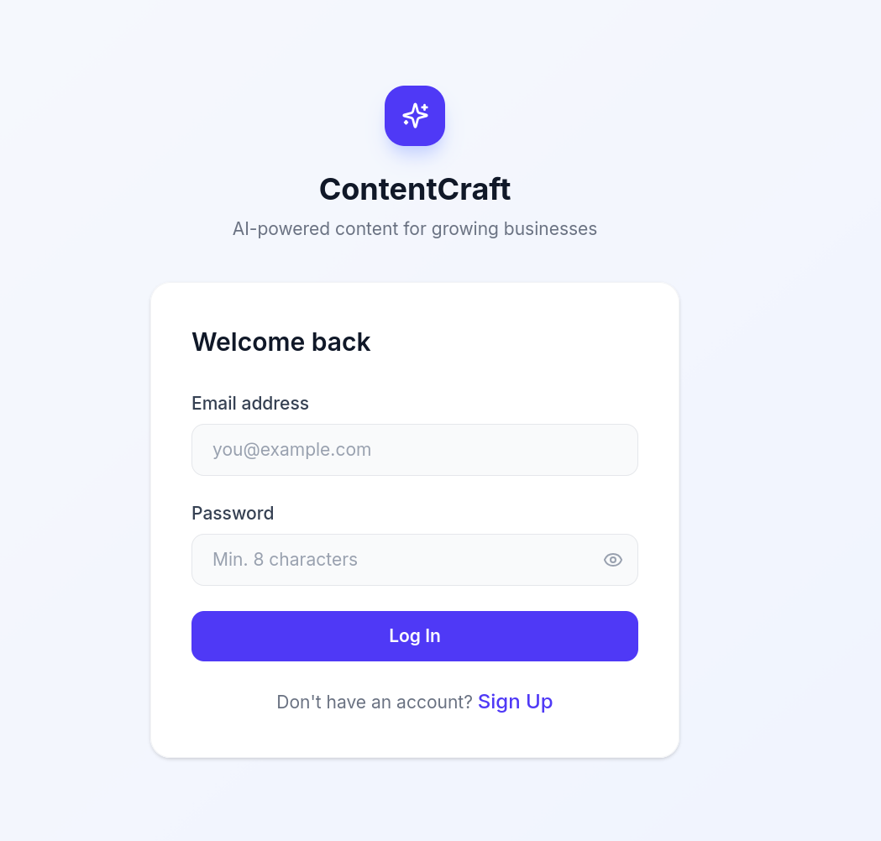

7.2 Dashboard Design

The dashboard is the user's home screen after login. It provides an at-a-glance view of their saved content and acts as the navigation hub for the platform.

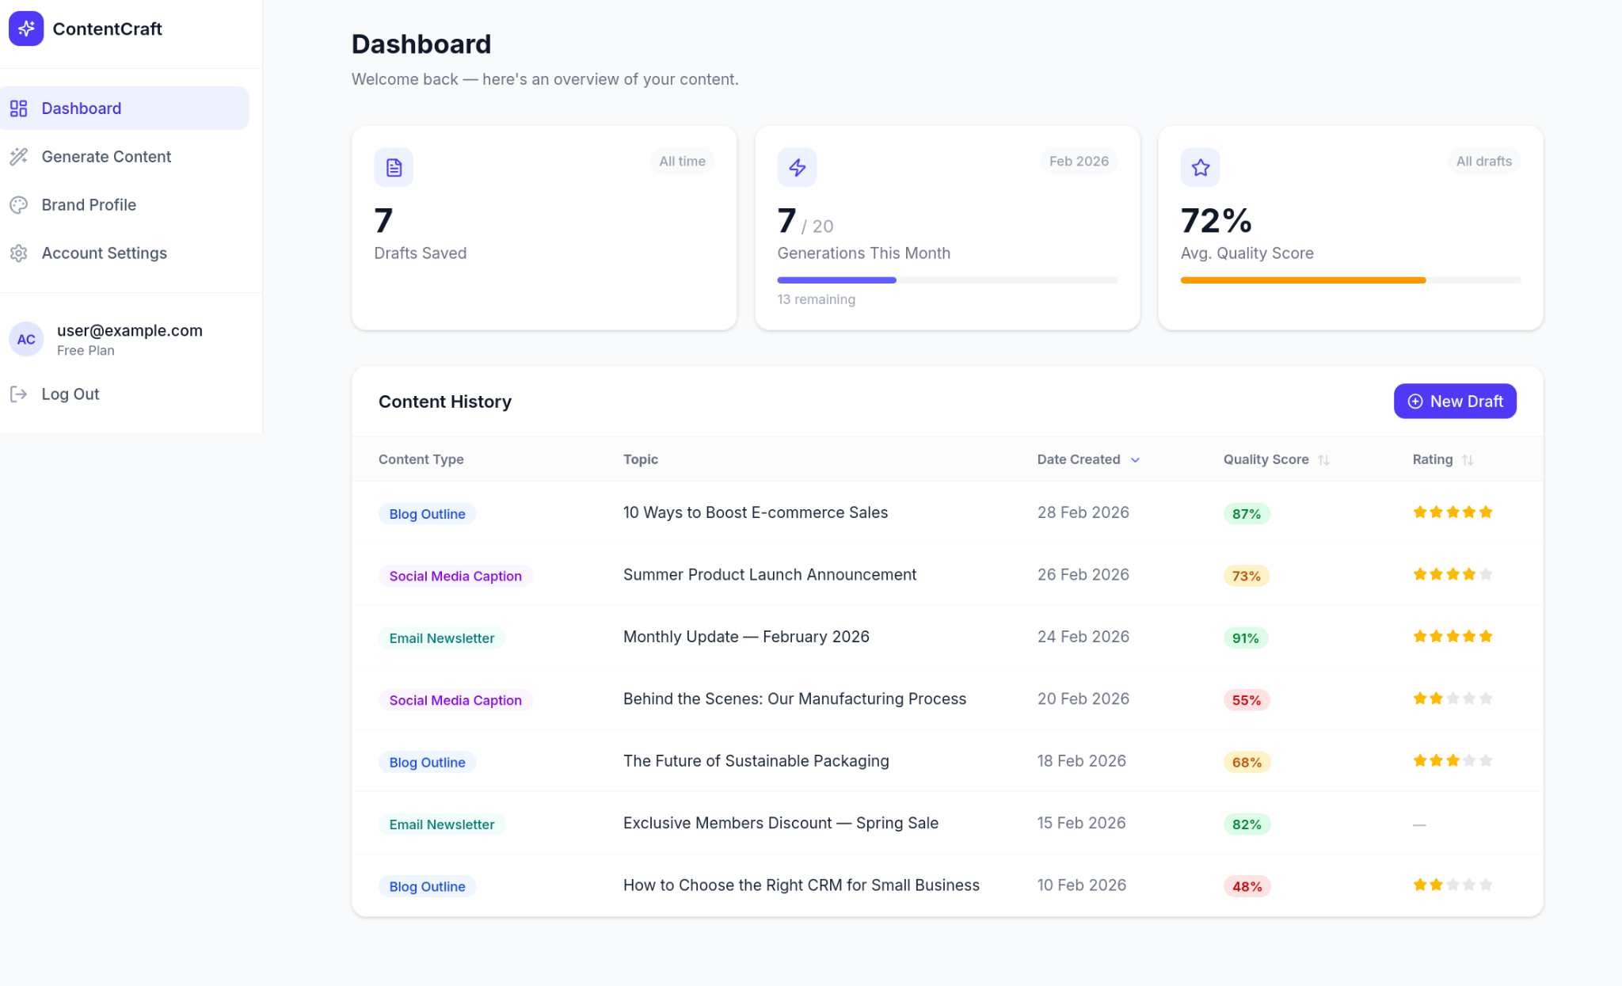

7.3 Content Generator Interface
The Content Generator is the core screen of the application. It is where the user initiates content creation, reviews AI output, and interacts with the quality evaluation. This screen must balance simplicity (non-technical users) with the depth of the generation pipeline (quality scoring, regeneration, feedback).
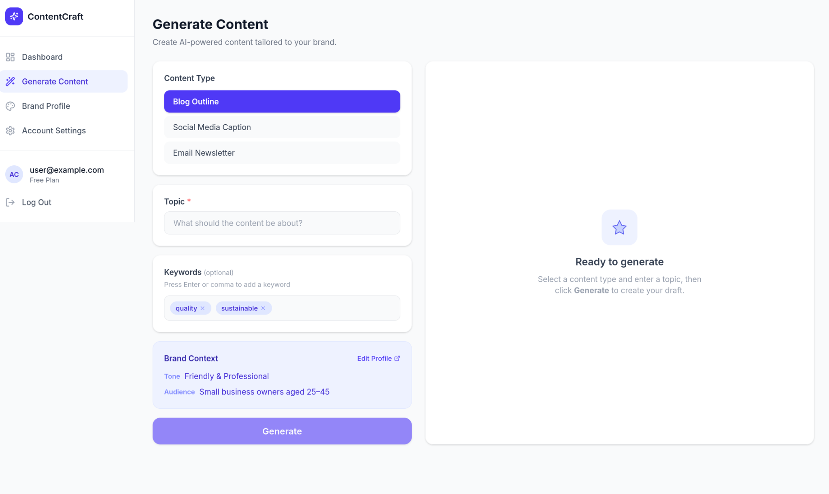

8 - Resource Management

8.1 Introduction

Effective resource utilization is central to the successful delivery of the AI-Powered Content Generation Engine. Because this project relies heavily on third-party AI integration, resources have been strategically allocated to ensure continuous system availability, secure data isolation, and rigorous evaluation of the AI-generated outputs. This section details the human, technical, and temporal resources required to transition this system from a conceptual proposal into a functional, measurable SaaS prototype.

8.2 Identification and Justification of Required Resources

6.2.1 Human Resources
To ensure deep technical execution and comprehensive system evaluation, the four-person project team is divided into specialized roles:

- Jamal (Backend Architect & Resource Manager): Responsible for mapping out system workflows (Sequence Diagrams), allocating project resources, configuring the Vercel serverless API routes, and integrating the OpenAI API with our automated evaluation logic.

- Daniel (Frontend Developer & UI/UX Lead): Responsible for translating complex system logic into accessible pseudocode and designing the high-fidelity user interface (UI Design). Daniel ensures the frontend React dashboard provides user-friendly mechanisms for capturing business profiles and displaying content quality scores.

- Semir (Requirements Analyst & Project Scheduler): Responsible for defining the core Functional Requirements and technical Use Cases. Crucially, Semir manages the overarching project Timeline, ensuring that all development phases and deliverables align strictly with the Capstone milestones and industry scheduling standards. Hailu (Risk Coordinator & Project Synthesizer): Responsible for conducting comprehensive Risk Management.

- Hailu identifies potential system and operational risks, formulates technical mitigation strategies, and synthesizes the overarching project Conclusion to ensure the final proposal aligns with our initial scope.

8.2.2 Technology and Software Resources
The project utilizes a modern, scalable cloud stack to minimize infrastructure overhead while meeting strict non-functional performance requirements:
- Supabase (Database & Authentication): Justification: Utilized for its robust PostgreSQL database and built-in Row-Level Security (RLS). Contribution: Essential for securely storing multi-tenant business profiles and archiving content drafts and evaluation metrics.
- Vercel (Cloud Hosting & API Routing): Justification: Provides serverless deployment capabilities with auto-scaling. Contribution: Ensures the system meets the non-functional requirement of handling 50 concurrent users without exceeding a 2-second interface latency.
- OpenAI GPT-4 / GPT-3.5 APIs (Core Engine): Justification: The primary generative models. Contribution: GPT-3.5 will be used for low-latency, short-form generation (e.g., social media), while GPT-4 will be utilized for complex, long-form content (e.g., blogs).
- Secondary NLP Evaluation APIs (e.g., Twinword): Justification: A secondary tool is required to objectively score the LLM’s output. Contribution: Fulfills the critical system requirement to benchmark generated content against the user's requested tone and SEO keyword density.
- GitHub (Version Control): Justification: Industry-standard collaborative coding environment. Contribution: Facilitates parallel development between Jamal and Daniel, ensuring code integrity and reliable backups.

8.2.3 Time Resources and Scheduling

The project will be managed using an Agile methodology, broken into structured phases across the implementation timeline:

- Phase 1 (Architecture & Database): Configuring Supabase schemas and securing authentication workflows.

- Phase 2 (API Integration & Benchmarking): Connecting the GPT API and developing the automated evaluation engine to score content.

- Phase 3 (Frontend & User Feedback): Building the dashboard, editor, and visual data representations.

- Phase 4 (Testing & Refinement): Load testing Vercel routes and conducting accuracy tests on the AI prompt templates.

8.3 Contingency Planning and Monitoring

To mitigate technical and operational risks, resource usage will be strictly monitored via weekly team meetings.

- Budgeting API Usage: Because OpenAI APIs operate on a pay-as-you-go token model, the team will utilize the cheaper GPT-3.5 model during development and testing phases to preserve financial resources, only escalating to GPT-4 for final benchmarking and the Capstone demonstration.

- Task Reallocation: Tasks will be tracked via a Kanban board on GitHub Projects. If a team member encounters bottlenecks (e.g., API integration delays), the team will practice cross-training, allowing members to reallocate hours and execute tasks in parallel to ensure milestones are not compromised

9 Risk Management

9.1 Risk Identification
Developing an AI-powered Software-as-a-Service (SaaS) platform presents technical and operational risks that can affect performance, security, and project delivery. Early identification enables the team to implement strategies that minimise negative impacts.
A key risk is AI content quality and hallucination. Large Language Models (LLMs) may generate inaccurate, irrelevant, or misleading marketing content. Without proper evaluation, this can undermine the platform's credibility with small business users. Because the system depends on automated content generation, maintaining output quality is essential for trust and usability.
API dependency and service availability are additional risks. The system relies on external AI services, such as the OpenAI API, to generate content. If these services are unavailable, experience latency, or reach usage limits, the platform may be unable to generate new content for users.
Data privacy and security are also critical risks. The platform stores business profiles, marketing information, and generated content in its database. Unauthorised access or data leakage between tenants could compromise confidential information and reduce user trust.
Performance and scalability are additional concerns. As user numbers grow, the system must handle increased requests to the AI service, database, and server infrastructure. Inefficient scaling may result in slow response times or system delays.
Project delivery risks may result from limited development time, integration challenges, or technical complexity. Because the project includes multiple components such as frontend development, backend services, database design, and AI integration, unexpected technical issues could delay implementation if not carefully managed.

9.2 Risk Mitigation Strategy

To address the identified risks, several mitigation strategies are incorporated into the system design and project management approach.
To reduce the risk of low-quality AI-generated content, the platform features a content evaluation module that automatically analyzes generated text using metrics such as readability, keyword relevance, and tone alignment with the business profile. Users can also rate content through a star-based feedback system. Together, these mechanisms create a feedback loop that improves prompt design and maintains high output quality over time.
To mitigate the risk of external API failures, the backend server uses fault tolerance and retry logic. If the AI API fails or times out, the system automatically retries with exponential backoff. If the request continues to fail, the system displays a user-friendly error message and preserves the user’s input data to prevent loss of work.
To manage data security and privacy risks, the system follows industry-standard security practices. All client-server communication is encrypted using HTTPS (TLS). User passwords are stored with secure hashing algorithms such as bcrypt. Row-Level Security (RLS) ensures each user can access only their own business data within the multi-tenant database.
Performance and scalability risks are addressed by deploying the platform on serverless cloud infrastructure, which enables automatic scaling based on user demand. The architecture separates frontend, backend, and database components to ensure efficient processing of AI requests and database operations without impacting overall platform performance.
Project management risks are mitigated through structured task allocation and regular team coordination. Each team member is responsible for specific technical components, and weekly progress reviews help identify potential delays early and allow for task redistribution if needed.
Through these mitigation strategies, the project aims to ensure the AI-powered platform remains secure and reliable, consistently delivering value to small business users.

10 Timeline & Milestone
The following is a project timetable for the development of the AI Content Generation Engine, commencing with the design phase on February 16, 2026 and ending with the project in November 2026.

10.1 NIT3003 – IT Capstone Project 1
At this phase, the "Logic Blueprint" of the AI Content Generation Engine is addressed, which includes the requirements and design of the AI Content Generation Engine.

Task ID | Component Name | Owner(s) | Start Date | End Date | Duration
1.1 | Research on AI Content Generation | Semir Abdu | 16/02/2026 | 22/02/2026 | 7 Days
1.3.1 | Introduction | Hailu Tesfaye | 17/02/2026 | 22/02/2026 | 6 Days
1.3.2 | Functional Requirements | Semir Abdu | 17/02/2026 | 22/02/2026 | 6 Days
1.3.3 | Non-Functional Requirements | Jamal Hussein | 17/02/2026 | 22/02/2026 | 6 Days
1.4.1 | Use Case Logic | Semir Abdu | 23/02/2026 | 07/03/2026 | 13 Days
1.4.2 | Sequence Diagram | Jamal Hussein | 23/02/2026 | 07/03/2026 | 13 Days
1.4.3 | Pseudocode | Daniel Palazzolo | 23/02/2026 | 07/03/2026 | 13 Days
1.4.4 | UI Design | Daniel Palazzolo | 23/02/2026 | 07/03/2026 | 13 Days
1.4.6 | Risk Management | Hailu Tesfaye | 23/02/2026 | 07/03/2026 | 13 Days
1.4.7 | Timeline & Gantt Setup | Semir Abdu | 23/02/2026 | 07/03/2026 | 13 Days
1.4.8 | Conclusion (Capstone 1) | Hailu Tesfaye | 23/02/2026 | 07/03/2026 | 13 Days

NIT3003 – IT Capstone Project 1 Gant Chart
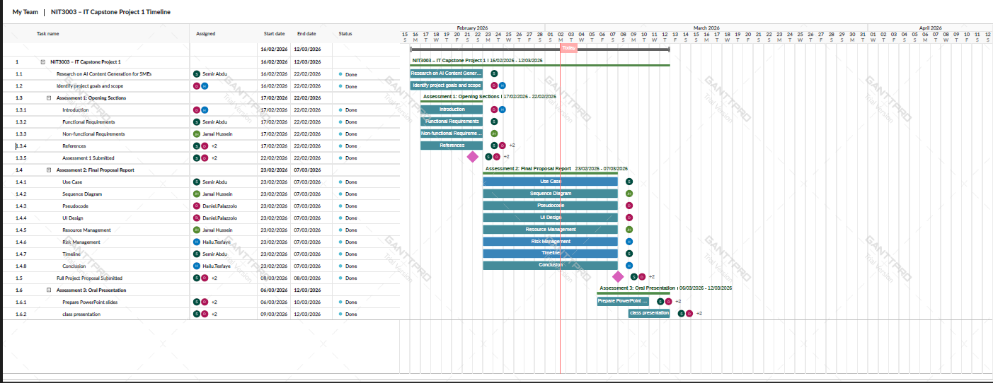

10.2 Project implementation
At this phase, the documentation of the Capstone Project 1 is transformed into a code and database format.

Task ID | Technical Component | Owner(s) | Start Date | End Date | Duration
2.1.1 | Environment Setup | Team | 13/03/2026 | 27/05/2026 | 76 Days
2.1.2 | Database Schema Design | Semir Abdu | 28/03/2026 | 30/04/2026 | 33 Days
2.1.3 | Content Table Implementation | Team | 01/05/2026 | 31/05/2026 | 31 Days
2.2.1 | AI API Integration | Jamal Hussein | 01/06/2026 | 15/07/2026 | 45 Days
2.2.2 | Prompt Engineering | Jamal Hussein | 16/07/2026 | 15/08/2026 | 31 Days
2.2.3 | Rating System Logic | Semir Abdu | 16/08/2026 | 31/08/2026 | 15 Days
2.3.1 | User Authentication | Hailu Tesfaye | 01/09/2026 | 20/09/2026 | 20 Days
2.3.2 | Content Display UI | Daniel Palazzolo | 21/09/2026 | 15/10/2026 | 25 Days

Project implementation Gantt chart
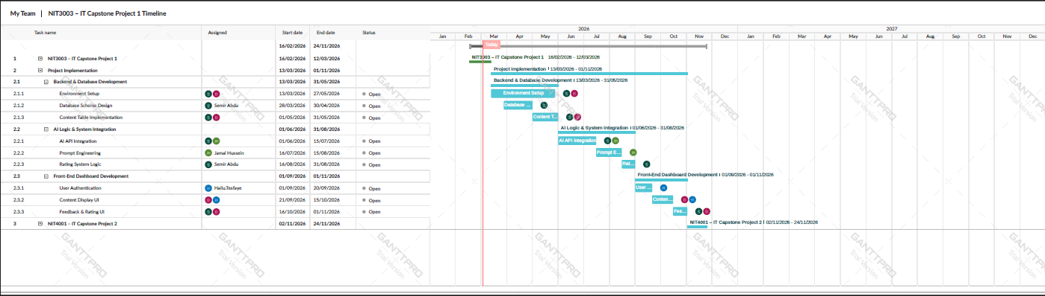

10.3 NIT4001 – IT Capstone Project 2
This is the final phase, which includes the benchmarking and the final oral presentation.

Task ID | Assessment Component | Owner(s) | Start Date | End Date | Duration
3.1.1 | Progress Diary | All Members | 02/11/2026 | 07/11/2026 | 6 Days
3.2.1 | Programming Code (Tech Build) | All Members | 09/11/2026 | 13/11/2026 | 5 Days
3.2.3 | Project Poster / ePoster | All Members | 09/11/2026 | 13/11/2026 | 5 Days
3.2.6 | Final Edits & Proofreading | All Members | 20/11/2026 | 21/11/2026 | 2 Days
3.3.1 | Final Oral Presentation | All Members | 23/11/2026 | 24/11/2026 | 2 Days

NIT4001 – IT Capstone Project 2 Gant chart
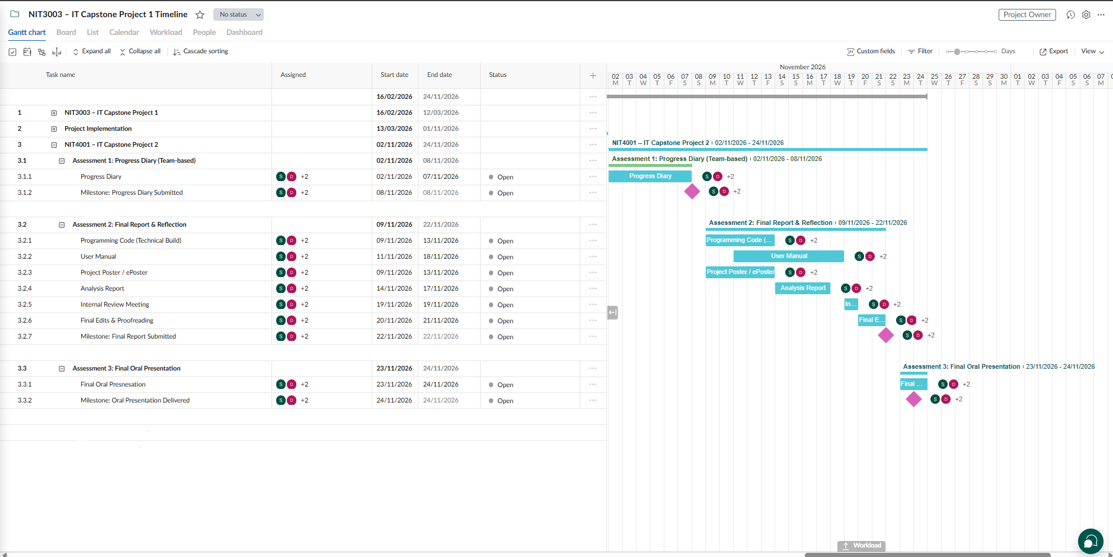

10.4 Contingency Planning

Logic Buffer: There is a buffer of one day between Capstone 1 (12/03) and Implementation (13/03) to synchronize the receipt of final proposal feedback.

Service Fallback: The system will fall back to GPT-3.5 Turbo when the latency of GPT-4 is beyond the performance requirement of 15-45 seconds.

Database Redundancy: The team will deploy a PostgreSQL instance when there is a downtime of Supabase (Task 2.1.2) to continue the development of the Rating System Logic.

11 Conclusion
This project proposal presents the design of an AI-powered content-generation platform for small businesses. The system addresses the challenges many small and medium-sized enterprises face in maintaining consistent digital marketing due to limited time, resources, and technical expertise. By leveraging Generative AI within a structured Software-as-a-Service platform, the solution enables businesses to efficiently generate professional marketing content while minimizing the complexity often associated with AI tools.
The proposal details the functional and non-functional requirements for the system, including user authentication, business profile management, automated content generation, and secure content storage. The system architecture addresses performance, security, scalability, and usability to ensure reliability and accessibility for non-technical users. Evaluation mechanisms for AI-generated content, such as readability analysis, tone alignment, and user feedback ratings, provide measurable quality benchmarks and enhance system reliability.

To support the system design, the proposal includes use cases, sequence diagrams, pseudocode, and user interface designs that illustrate user interactions and system communication with external AI services. It also addresses resource management and risk mitigation strategies to ensure effective implementation and to manage challenges such as AI output accuracy, system scalability, and data security.

Overall, the proposed AI-powered platform demonstrates how generative AI can be integrated into practical business tools to help small businesses manage marketing activities more efficiently. By combining automated content generation with structured evaluation and user feedback, the system aims to deliver reliable, high-quality marketing content that remains accessible to users without advanced technical knowledge. Successful implementation would showcase the potential of AI-driven solutions to enhance productivity, innovation, and competitiveness for small businesses in the digital economy.

12 Contribution table
Hailu Tesfaye (s8137538) | Introduction (including references)  1.1 Background  1.2 Problem Statement  1.3 Proposed Solution  Risk Management  Conclusion
Semir Abdu (s4672665) | Functional Requirements (including references)  - 2.1 Overview  - 2.2 Front-End Functional Requirements  - 2.3 Business Profile Management  - 2.4 Content Generation  - 2.5 Content Storage and Management Dashboard  - 2.6 Server-End Functional Requirements  - 2.7 Data Storage Requirements  - 2.8 Database Requirements  - 2.9 System Flow  Use Case  - 4.1 Use Case 1: Create and update Business Profile  - 4.2 Use Case 2: Generate AI Marketing Content  - 4.3 Use Case 3: Manage Saved Content  - 4.4 Use Case Diagram sketch  Timeline & Milestone  - NIT3003 – IT Capstone Project 1  - Project implementation  - NIT4001 – IT Capstone Project 2  - Contingency planning  References
Jamal Hussein (s8081019) | Non-Functional Requirements (including references)  - 3.1 System Scalability and Multi-tenancy  - 3.2 System Reliability and Uptime  - 3.3 Performance and Latency  - 3.4 Security and Data Privacy  - 3.5 Usability and User Experience  Sequence Diagram  - 5.1 System Interaction Overview  - 5.2 Sequence Diagram Image  - 5.3 UML source code  Resource Management  - 8.1 Introduction  - 8.2 Identification and Justification of Required Resources.  - 8.2.2 Technology and Software Resources  - 8.2.3 Time Resources and Scheduling  - 8.3 Contingency Planning and Monitoring
Daniel (s8177269) | Introduction (including references)  - 1.4 Project Aim and Objectives  1.5 Project Scope .  1.6 Significance of the Project  Pseudocude  UI Design

13 . Reference
Cillo, P., & Rubera, G. (2024). Generative AI in innovation and marketing processes: A roadmap of research opportunities. Journal of the Academy of Marketing Science.
https://doi.org/10.1007/s11747-024-01044-7
Keegan, B. J., Dennehy, D., & Naudé, P. (2022). Implementing artificial intelligence in traditional B2B marketing practices: An activity theory perspective. Information Systems Frontiers.
https://doi.org/10.1007/s10796-022-10294-1
Liando, I. B., Rumokoy, L. J., & Tumewu, F. J. (2024). The impact of AI adoption, digital marketing, and customer engagement on the perceived business growth of SMEs. Asian Journal of Applied Business and Management. Retrieved from
https://npaformosapublisher.org/index.php/ajabm/article/view/603

Rosário, A. T., & Raimundo, R. J. (2025). The integration of AI and IoT in marketing: A systematic literature review. Electronics, 14(9), 1854.
https://doi.org/10.3390/electronics14091854

McKinsey & Company. (2023). The economic potential of generative AI: The next productivity frontier. Retrieved from
https://www.mckinsey.com/capabilities/quantumblack/our-insights/the-economic-potential-of-generative-ai-the-next-productivity-frontier
Microsoft. (2023). What is SaaS (Software as a Service)? Microsoft Azure. Retrieved from
https://azure.microsoft.com/en-au/resources/cloud-computing-dictionary/what-is-saas/

OWASP Foundation. (2023). Password storage cheat sheet. Retrieved from
https://cheatsheetseries.owasp.org/cheatsheets/Password_Storage_Cheat_Sheet.html

